18. Display every order along with the details of that order for order numbers 10270, 10272, 10279 (23)

SELECT \* FROM orders

NATURAL JOIN orderDetails

WHERE orders.ORDERNUMBER IN (10270, 10272, 10279);

select \* from orders natural join orderdetails where ordernumber = 10270 or ordernumber = 10272 or ordernumber = 10279

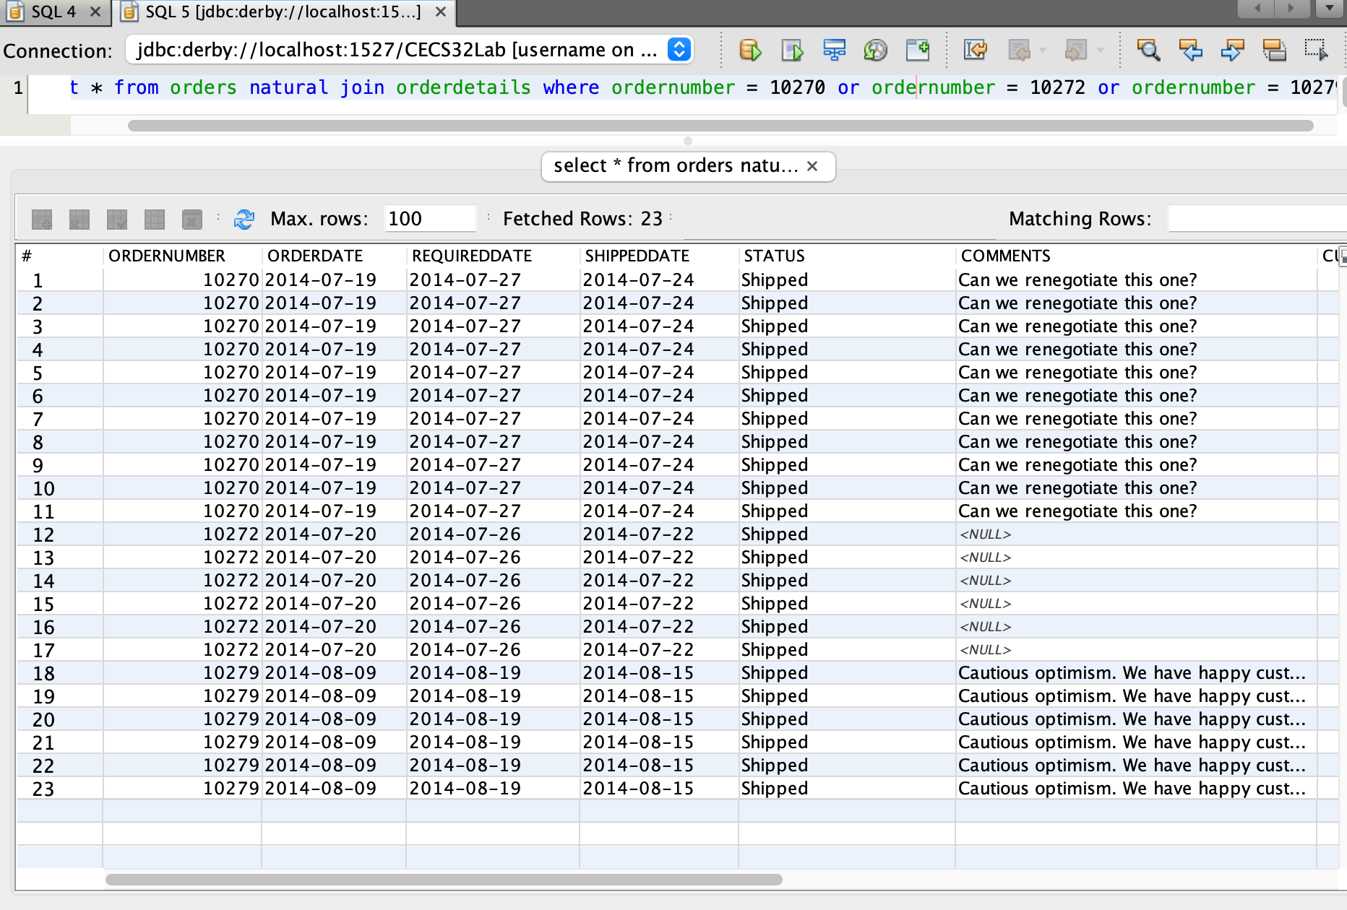

19. List of productlines, the productline’s text description and vendors that supply the products in that productline ordered by productLine and productVendor. (65)

select distinct productline, productlines.TEXTDESCRIPTION, productVendor from productlines natural join products where products.productline = productlines.productline order by productline, productVendor

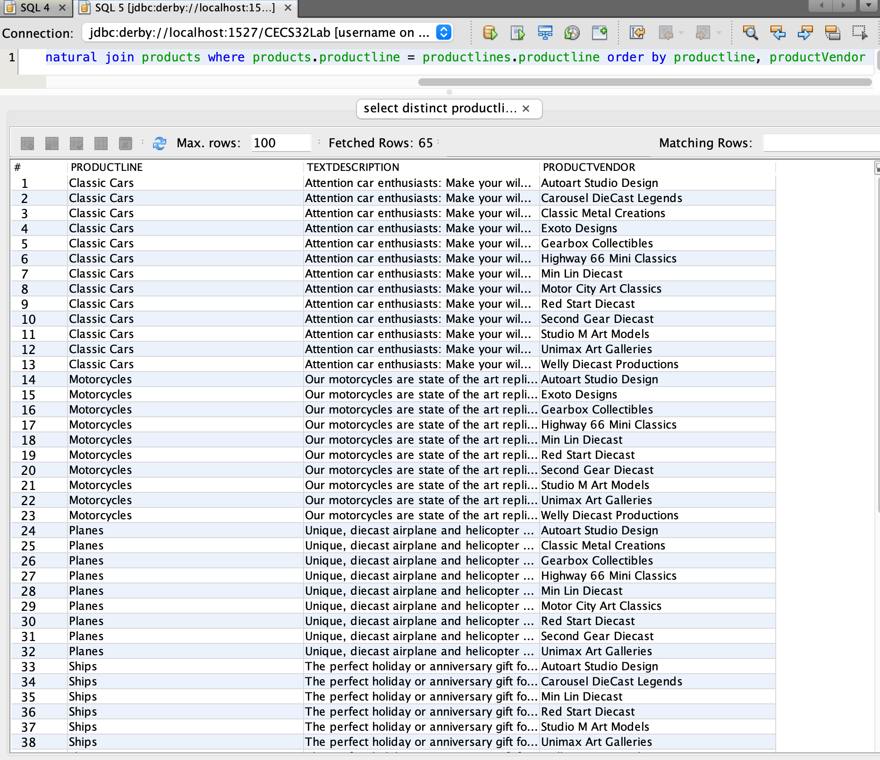

20.select customers that live in the same state as one of our offices ordered by customerName (26)

select \* from customers inner join offices on customers.state = offices.state order by customername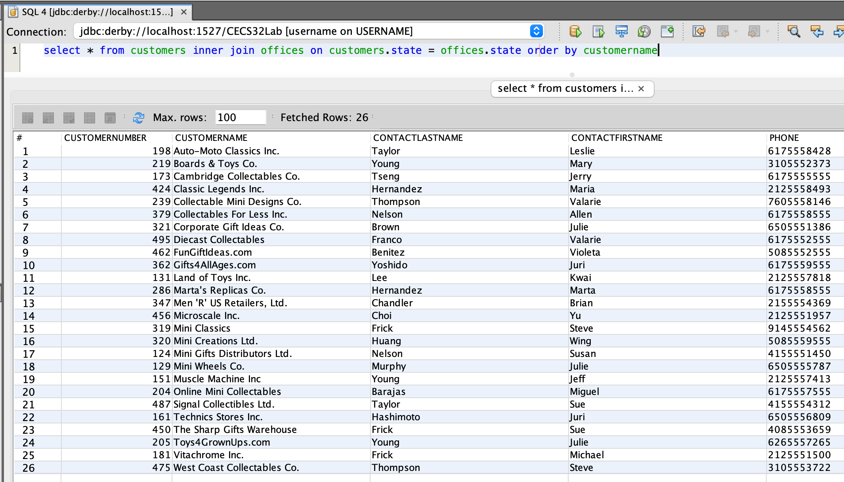

21.select customers that live in the same state as their employee representative works (26)

select \* from customers inner join employees on customers.salesrepemployeenumber = employees.EMPLOYEENUMBER inner join offices on employees.OFFICECODE = offices.OFFICECODE where customers.state = offices.state

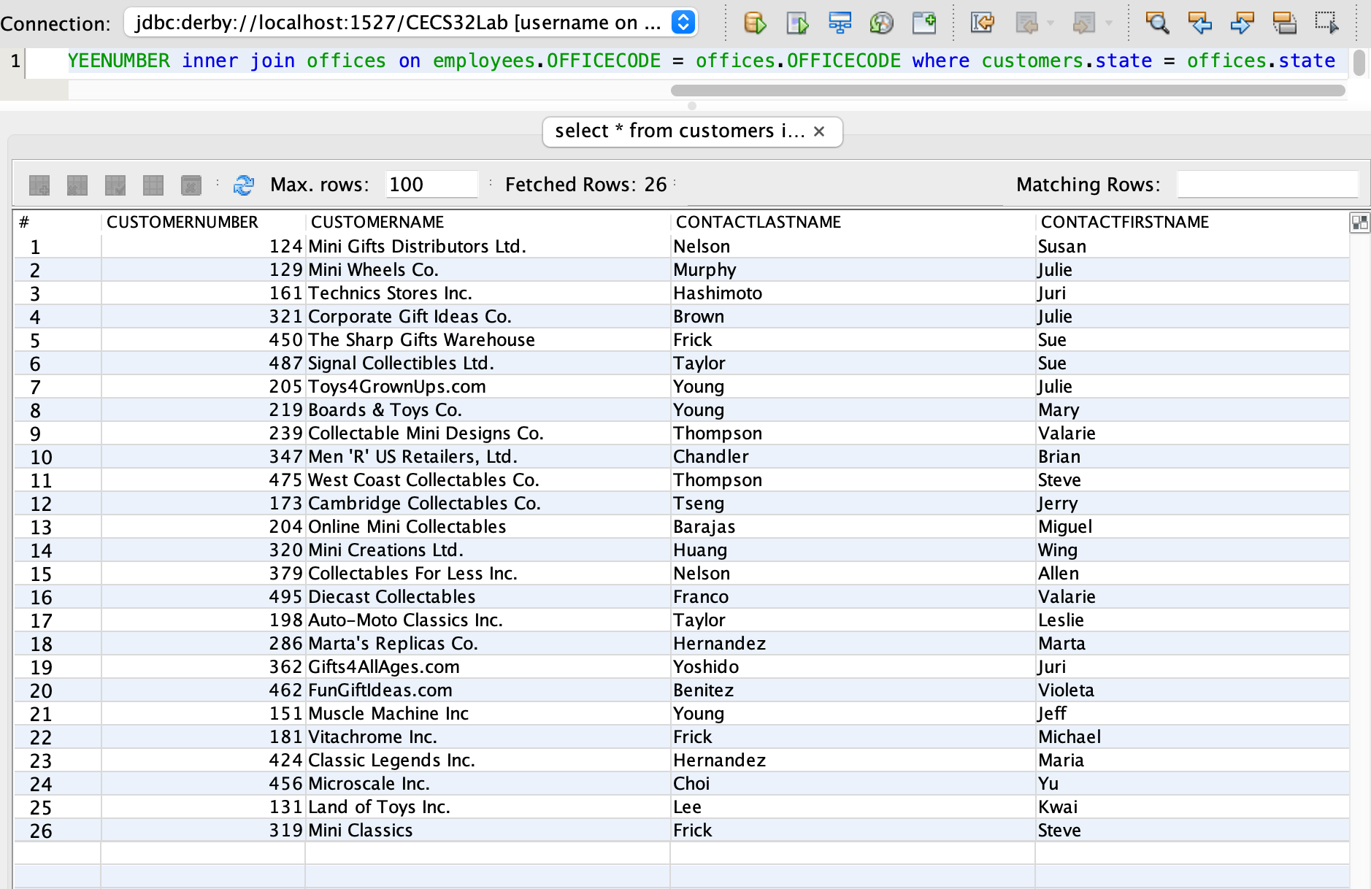

22. select customerName, orderDate, quantityOrdered, productLine, productName for all orders made and shipped in 2015 (444)

select customerName, orders.orderDate, orderDetails.quantityOrdered, productLine, productName from customers natural join orders natural join orderDetails natural join products where year(orders.orderdate) = 2015 and year(orders.SHIPPEDDATE) = 2015

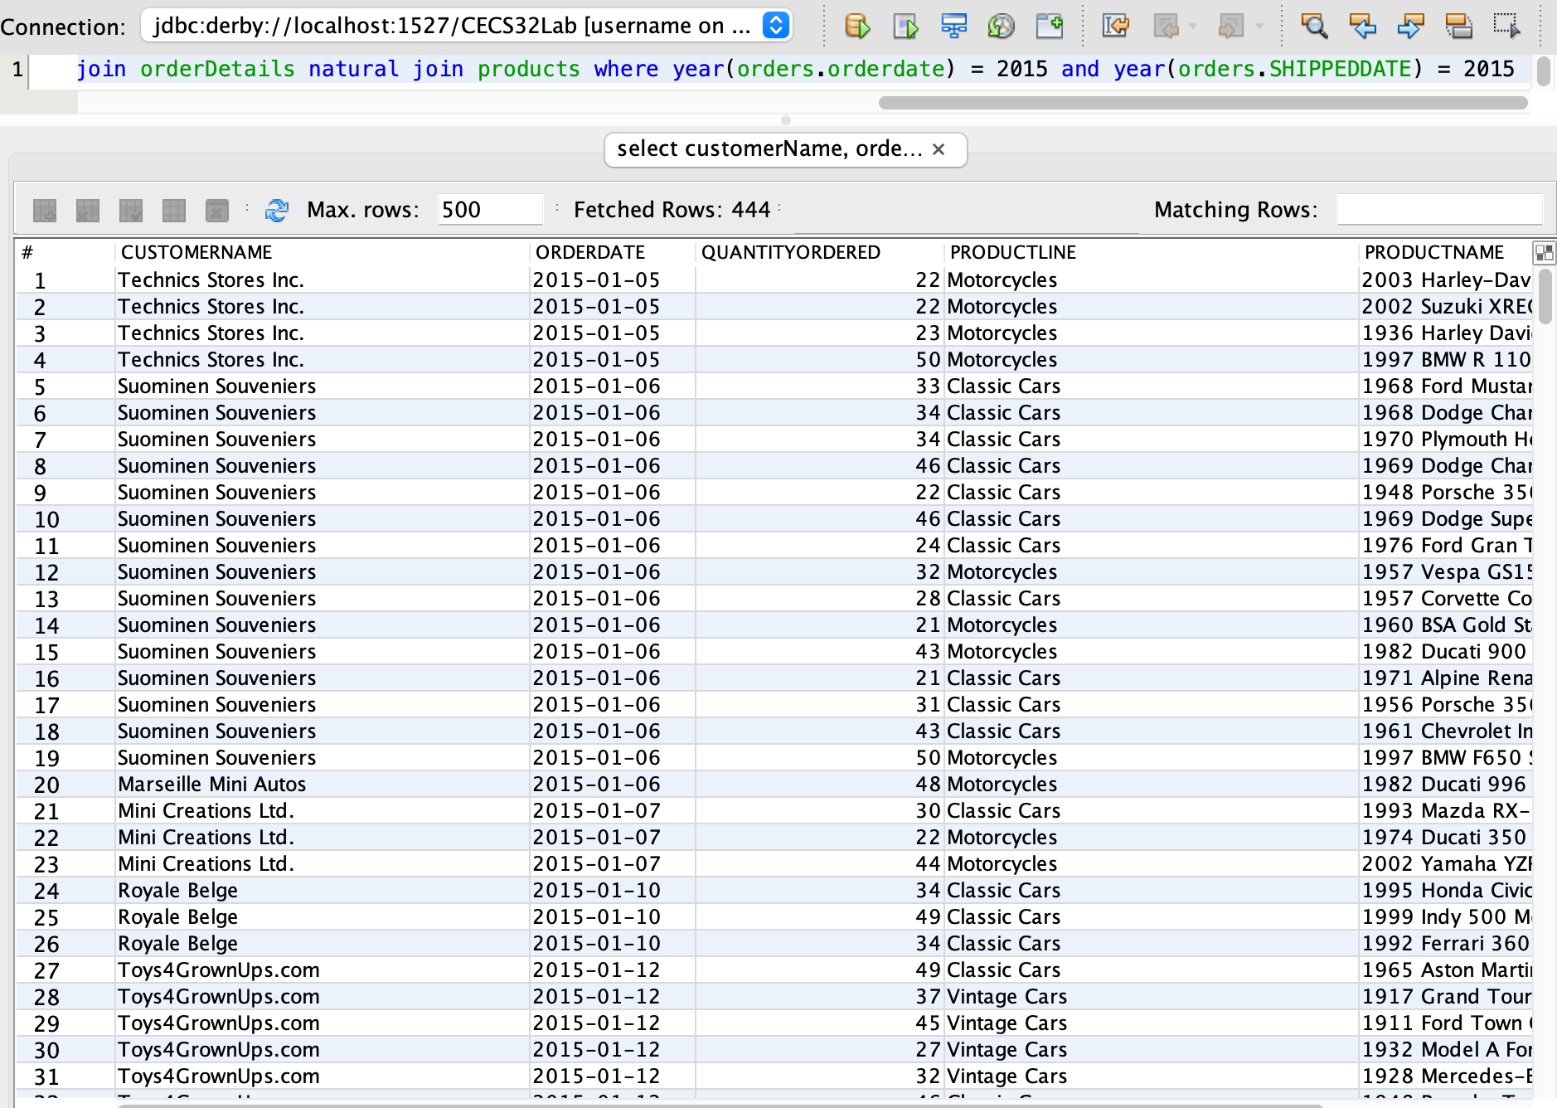

23. List products that didn't sell (1)

SELECT productname, ordernumber

FROM Products LEFT OUTER JOIN OrderDetails

ON Products.productcode = OrderDetails.productcode

WHERE ordernumber IS NULL;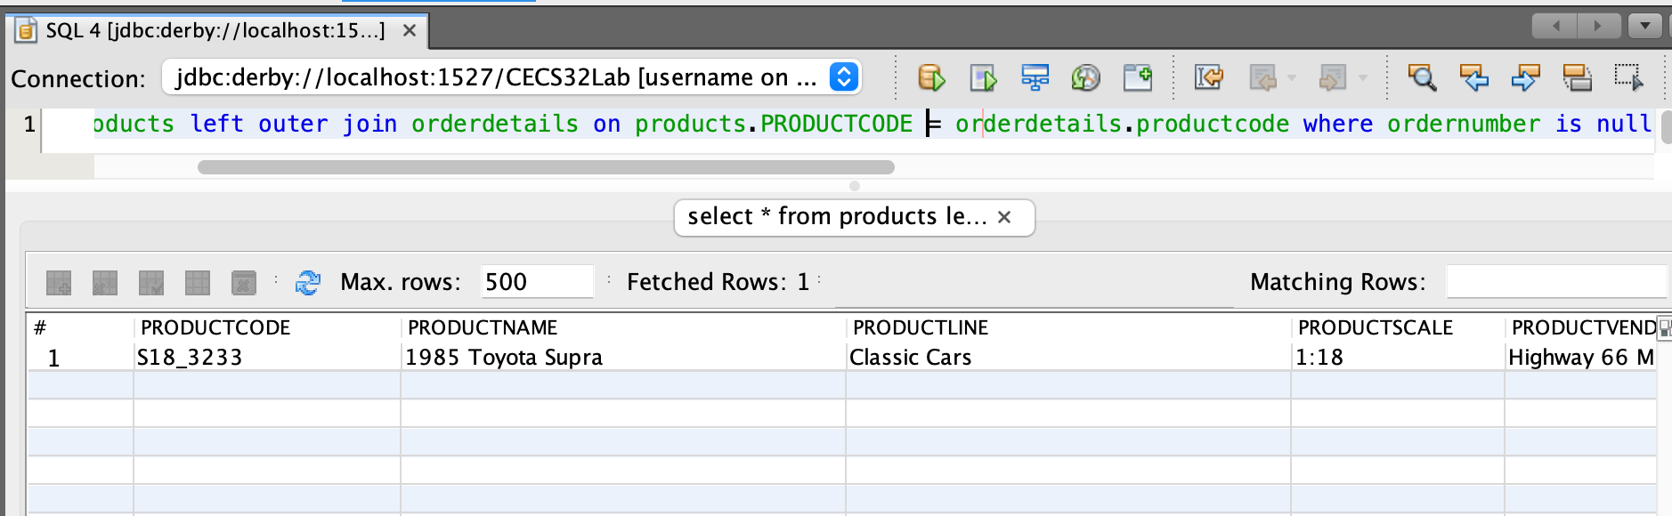

24. List all customers and their sales rep even if they don’t have a sales rep order by customerName (122)

select \* from customers left outer join employees on customers.SALESREPEMPLOYEENUMBER = employees.EMPLOYEENUMBER order by customername

